GEN AI ASSIGNMENT-3

1. Build a complete HTML + JavaScript frontend for student registration and login using Supabase.

Connecting project to the loveable

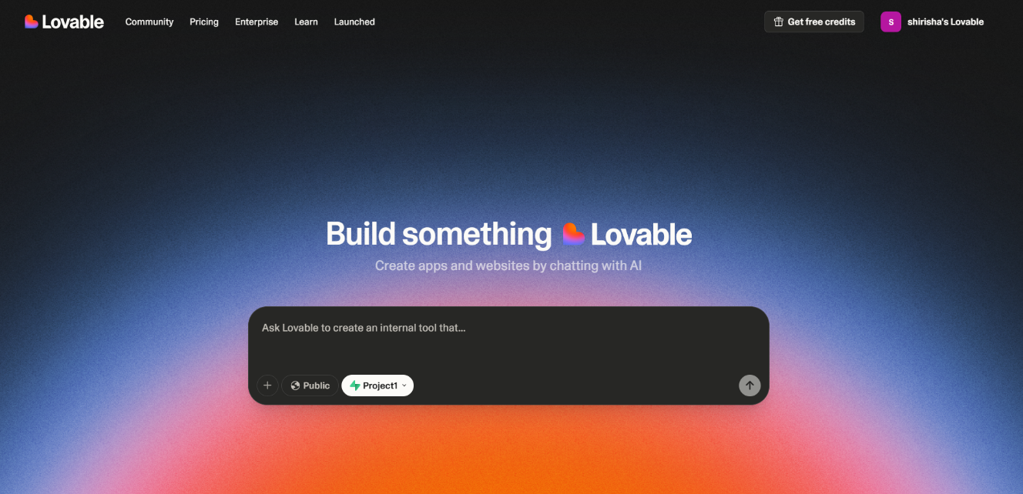

Connecting supabase

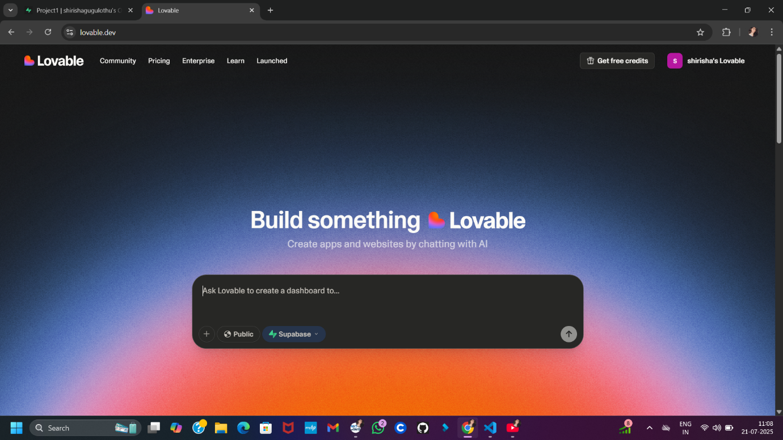

Giving prompt to the loveable to build a complete HTML + JavaScript frontend for student registration and login using Supabase.

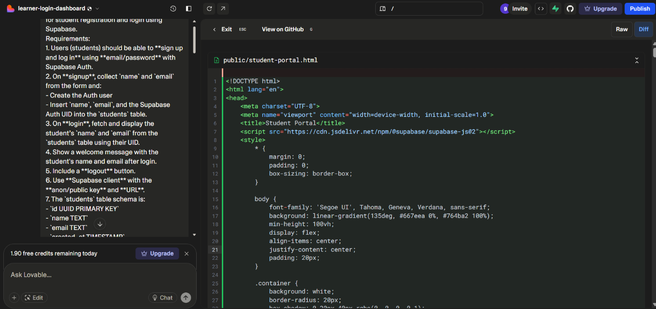

Created a login page using loveable and logged in successfully

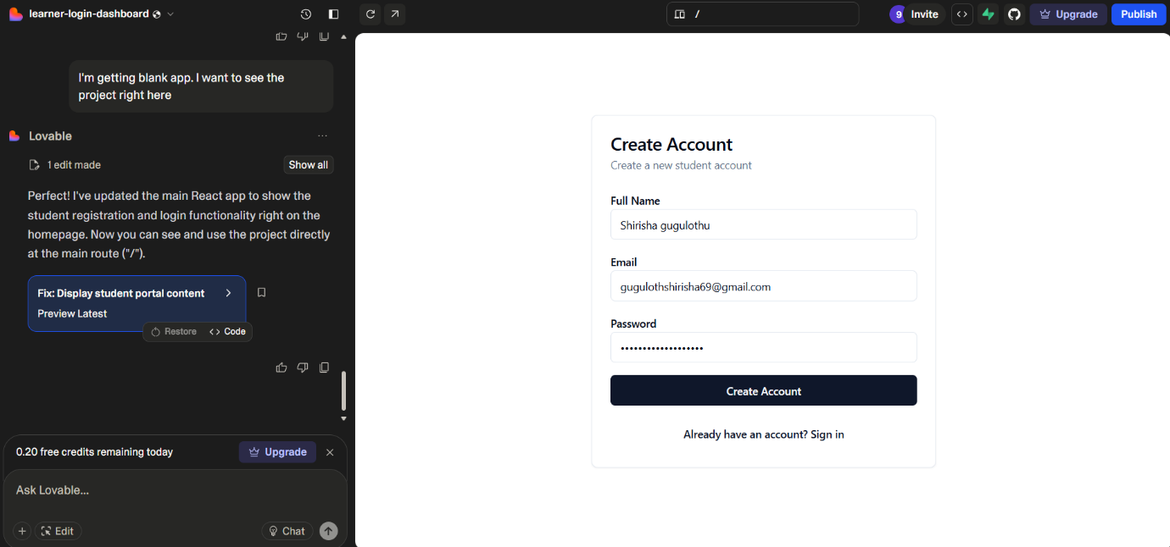

Created a student dashboard successfully and logged out

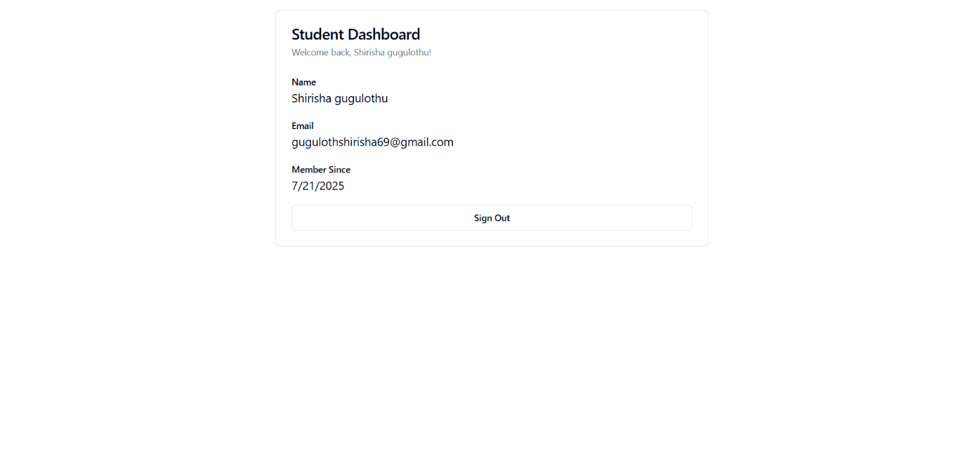

Conclusion:

Lovable’s **chat based workflow** allowed me to describe the dashboard and flow in plain English generating UI, database schema, and authentication steps without writing code manually.

I **connected to my Supabase project**, created the student table schema, and applied it.

Lovable then **generated and deployed Edge Functions** (e.g. for processing student data or sending notifications) using my Supabase-backed secret storage, without exposing keys in code loveable documentation.

With **smart debugging features**, Lovable automatically surfaced Supabase Edge Function logs and deployment errors in its interface—helping me identify and resolve issues more efficiently.